1) Create one VPC,with 1 one public subnet and 1 private subnet.

2) Enable VPC peering for cross region.

3) Enable VPC peering for cross account. (You can collaborate with your friend and do this task).

4) Setup VPC Transist gateway.

5) Setup VPC End Point.

**1) Create one VPC,with 1 one public subnet and 1 private subnet.**

**Imran-vpc created with 1 public subnet and 1 private subnet**

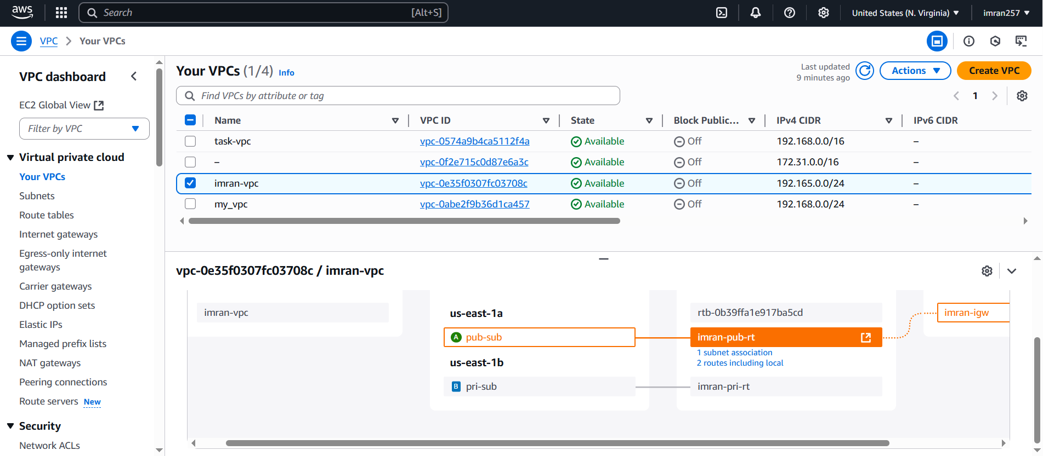

**2) Enable VPC peering for cross region.**

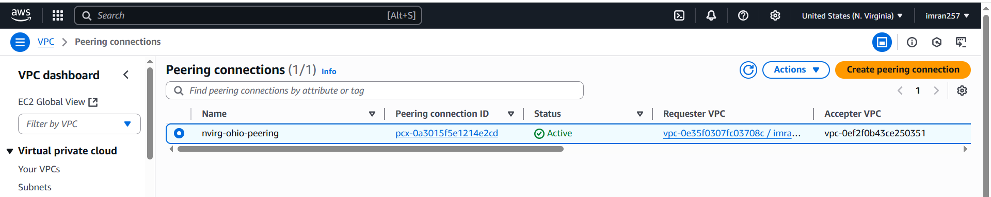

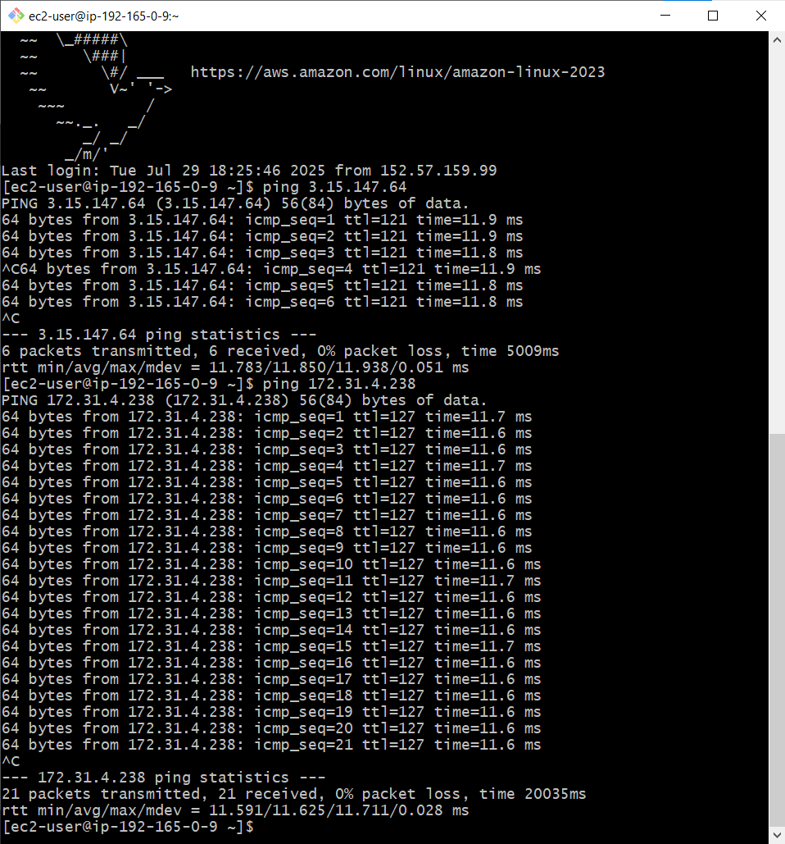

**3) Enable VPC peering for cross account. (You can collaborate**

**with your friend and do this task).**

1. **Created one instance with selecting my-vpc.**
2. **Connected to my pub-subnet**
3. **Created a peer connection with requester my-vpc and accepter yunus aws account id and his vpc id and his region**
4. **In route tables entered the yunus cidr range 192.164.0.0/20 in target selected peering connection.**
5. **Once accepter accepted the request he also edit his route with my cidr range and selected peering connection.**
6. **Now able to ping each other.**

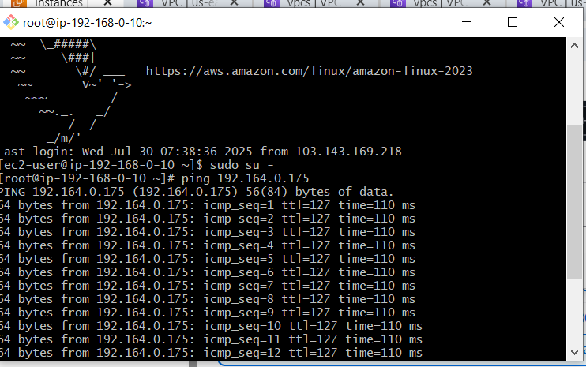

**4) Setup VPC Transit gateway.**

**Requirements:**

1. **Create Transit Gateway**
2. **TGW Attachments for both VPC-A and VPC-B**
3. **TGW ID**
4. **Each VPC has subnets and EC2 instances.**

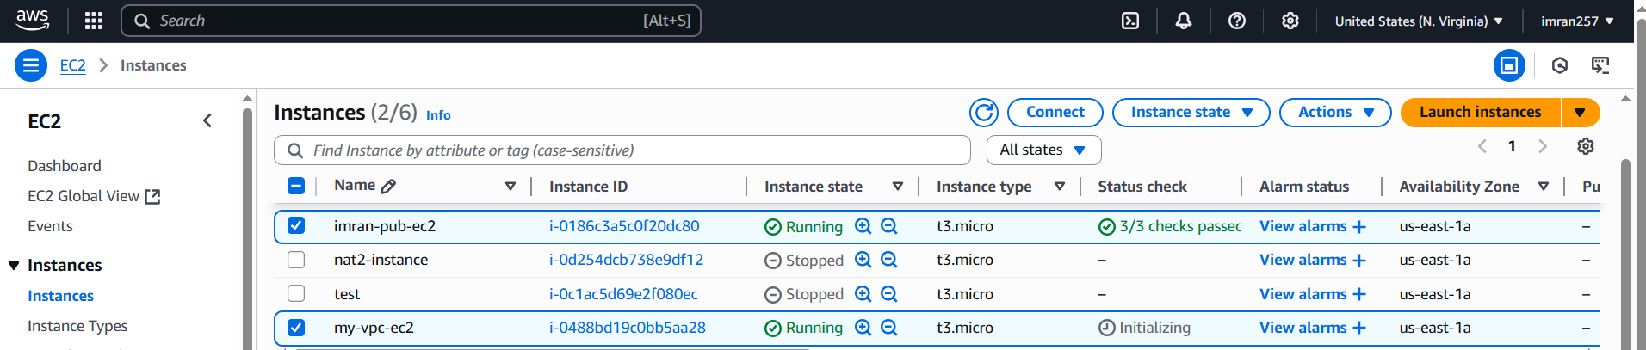

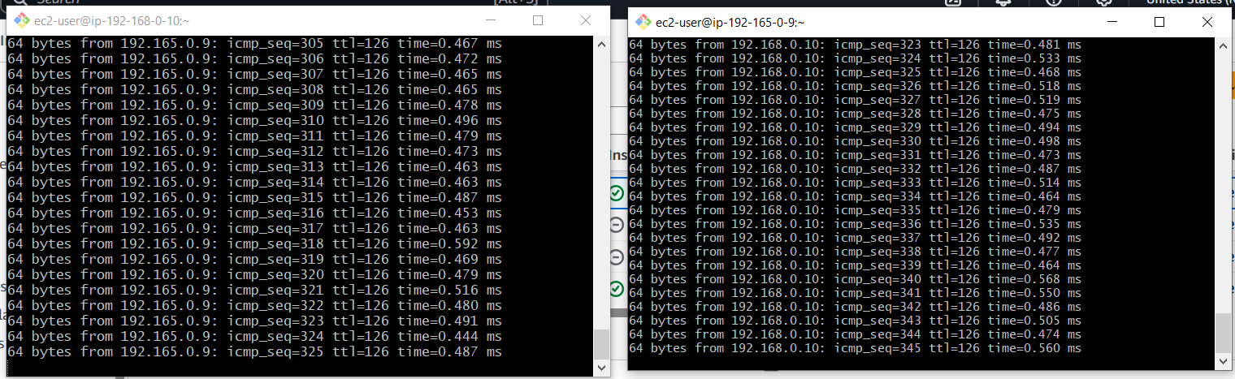

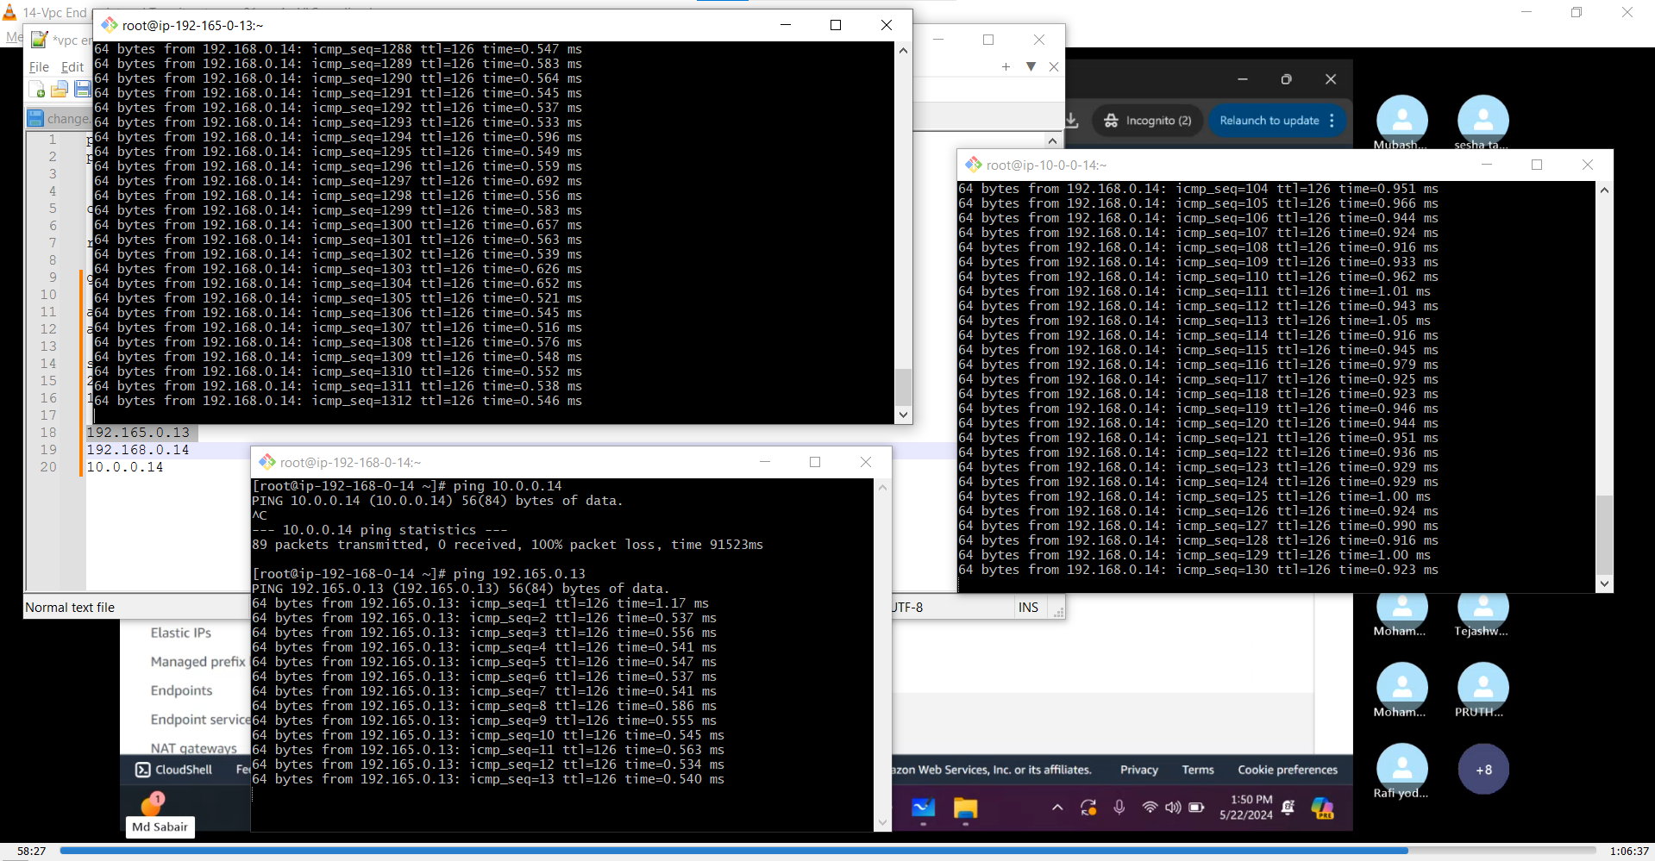

**5) Setup VPC End Point.**

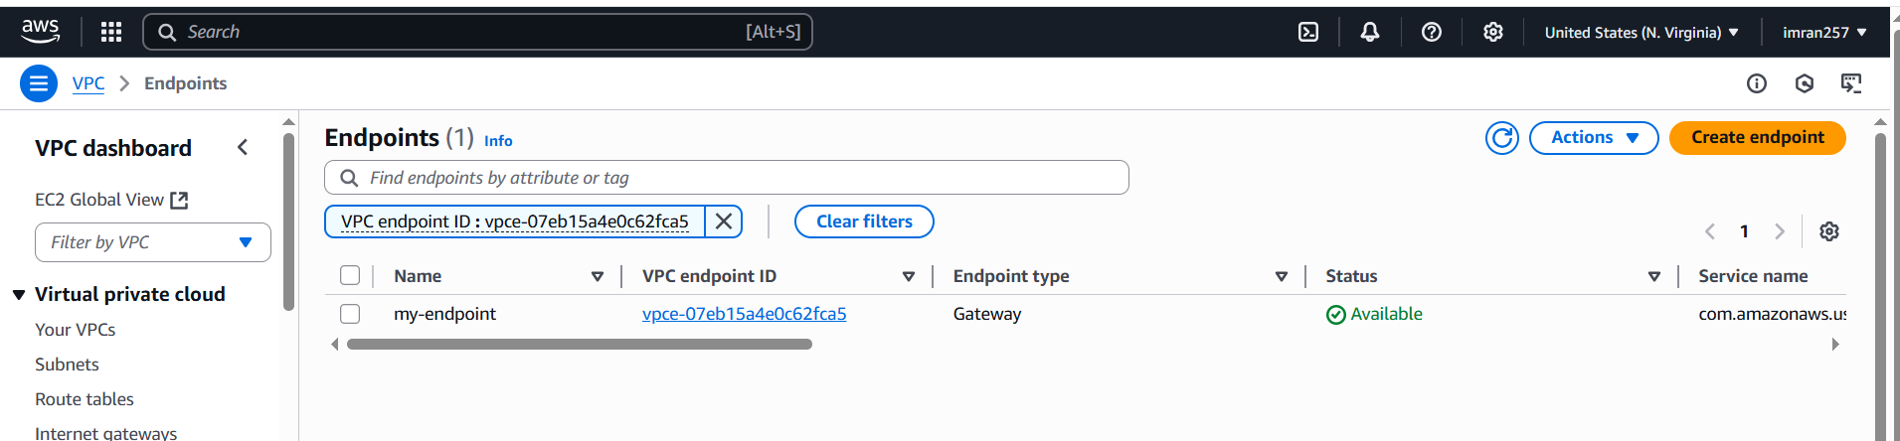

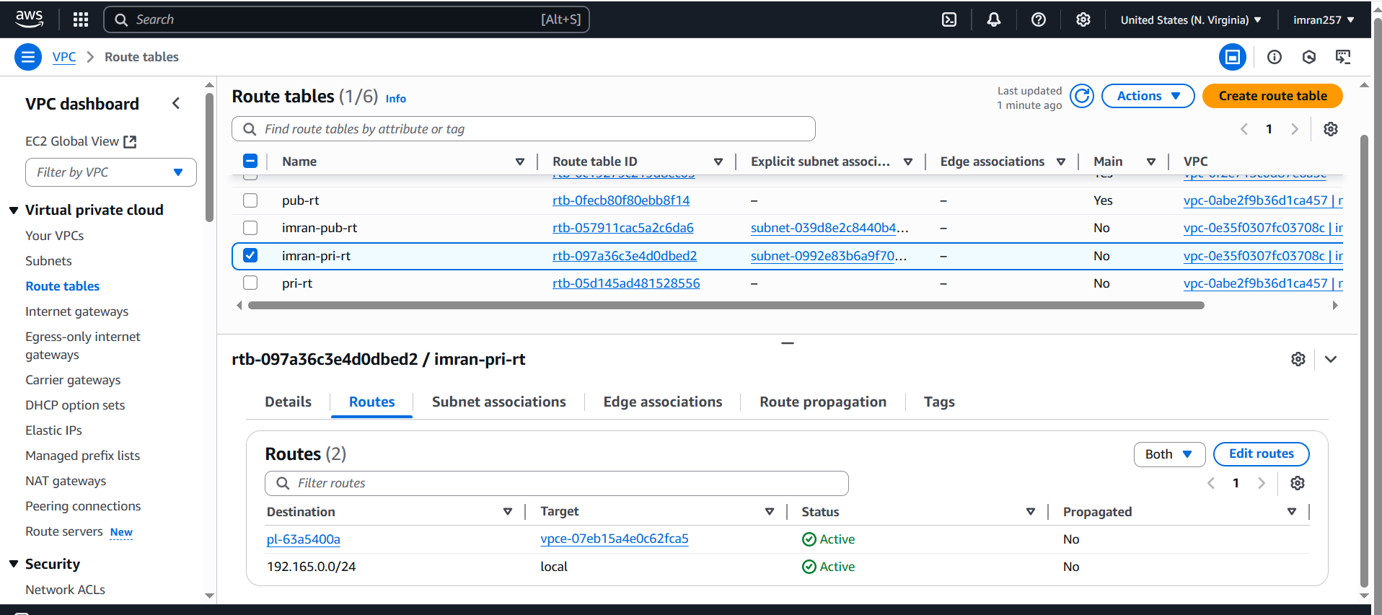

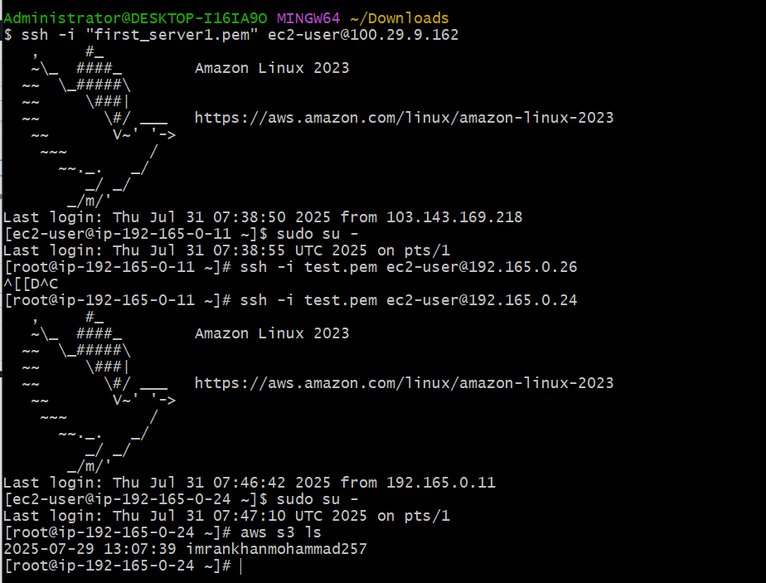

1. **Create a END POINT with having service** [**com.amazonaws.us**](http://com.amazonaws.us)**-east-1.s3 (Gateway) select your vpc and then create.**
2. **Through public ec2 we are connecting private ec2(which have no public ip and no NAT Gate way)**
3. **Now we are in private ec2 then aws configure.(give access point id and key)**
4. **Check aws s3 ls → then s3 bucket will show.**
5. **Through VPC end point it happens in private EC2.**